# National Geographic Kids -

National Geographic kids is basically a website that try to teach kids about different animals and places. Through their interactive games and videos.

Inside the website there are different sections of games and videos that have puzzle games as well as different videos about facts and figures.

**All their platforms contain an encyclopedia type page that contains different species. And information about animals that come under these species.**

And this is the highlight of the National Geographic kids there encyclopedia type page that teaches kids about different species of animals.

Also there are other sections too in the site like history, science space etc. And most of the contents in these sections are in the form of blogs.

## Design Point of view -

From the design point of view the website uses the two color code combination

1. 009c00 - Green
2. Ffcc02 - Yellow

## Some screenshot -

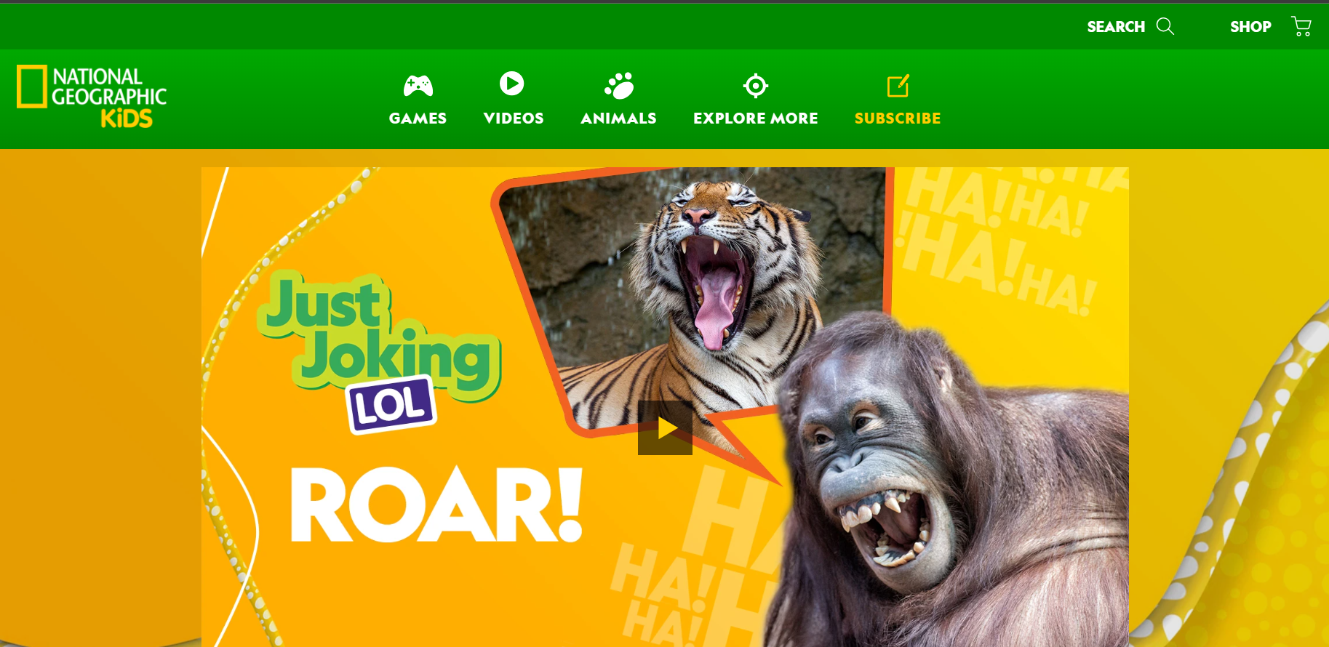

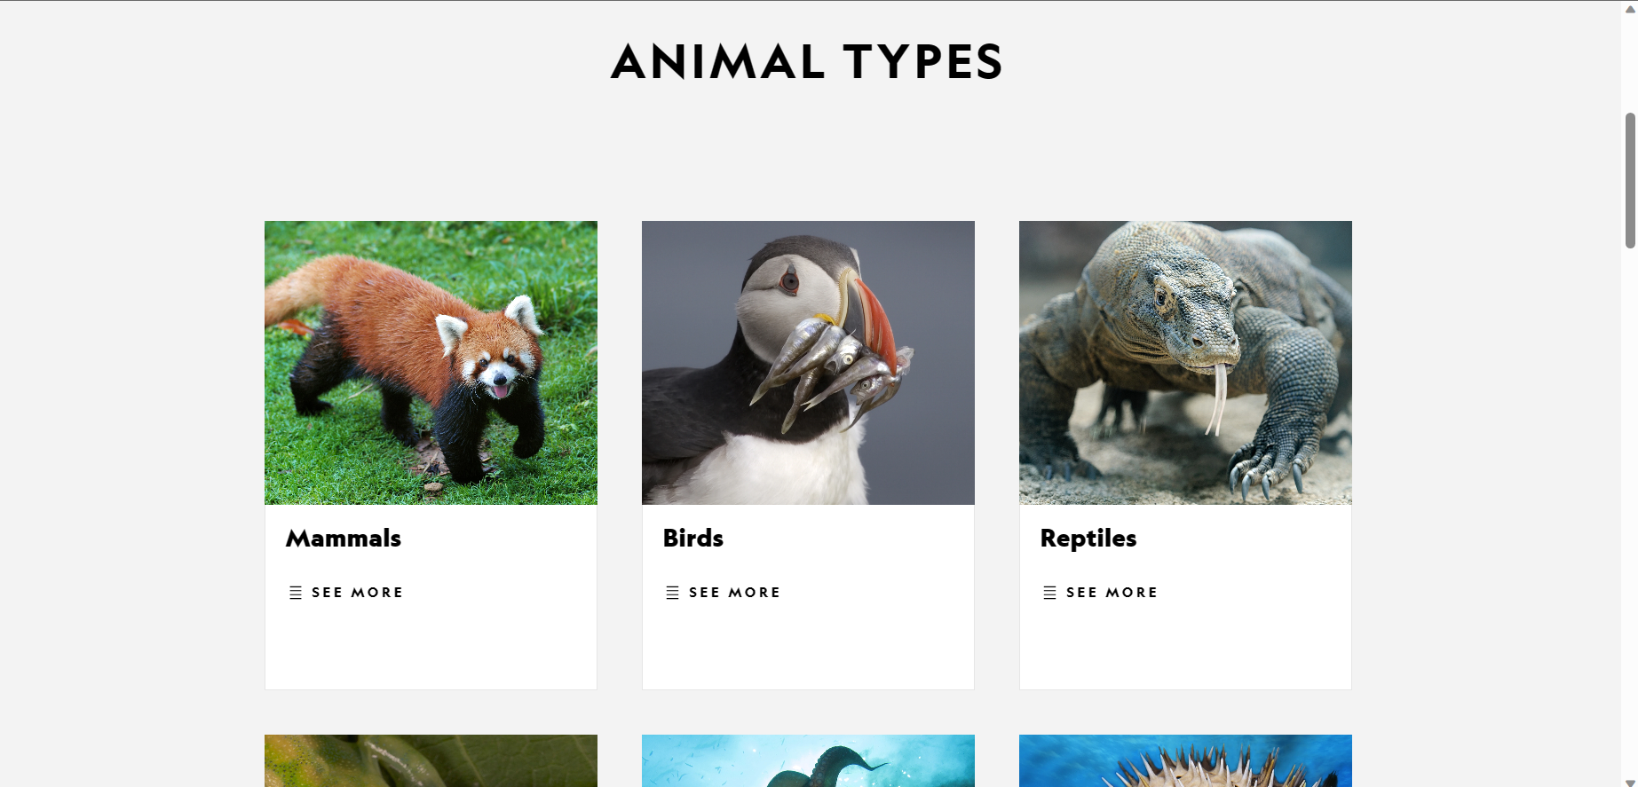

# 2. FunBrain -

Fun brain is the type of website / platform that follows the concept that we are trying to build.

For example it follows the format of **grade wise group dividing**.

In funBrain the groups are divided into 1st to 8th and each grade has different types of games and levels according to their grades.

Not only games but there is a reading section too in the platform that provides different reading content in the style of comics to build a good understanding of kids in language and trying to introduce new words to them.

Video sections are also found in FunBrain but they are most likely for entertaining purposes and as compared to national geography they are of low quality.

**But the main attraction of the website is there different maths solving problems in game format. Which is something to check out or take a reference from.**

## Design point of view -

From the point of view of design websites look and feel very premium and minimalistic. For sure it is made for kids but it give a professional feel when we scroll through it.

## Color Combination -

1. 8a719e
2. F0ece7
3. 1f1c1a

Also the menu of the website looks very catchy and elegant.

## Screenshots -



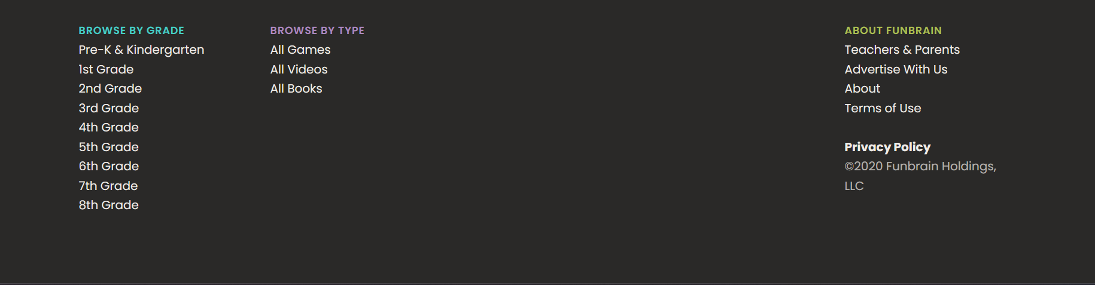

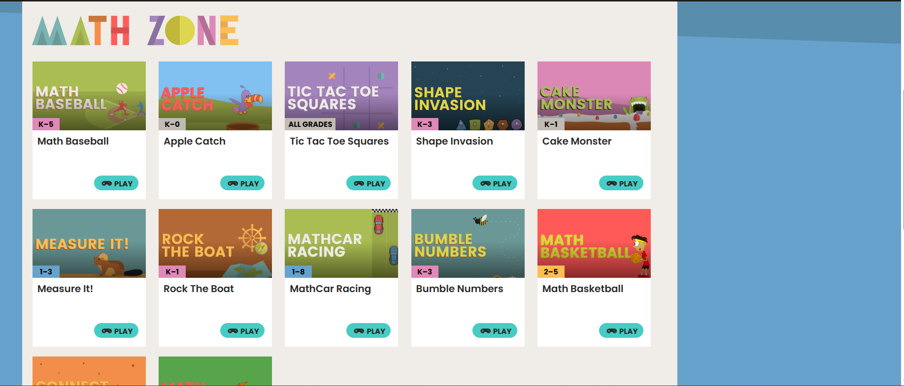

# 3. CodinGame -

CodinGame is more like a professional coding website and if we compare it to our project then it is completely different on one hand our platform focuses on teaching kids different skills in which maybe we will focus on programming in future. But the CodinGame is for the people who already know the programming and want to sharpen their coding skills.

So CodinGame is quite a different thing and from this website it is quite difficult for us to pick up something that we can use for our platform.

## Screenshot -

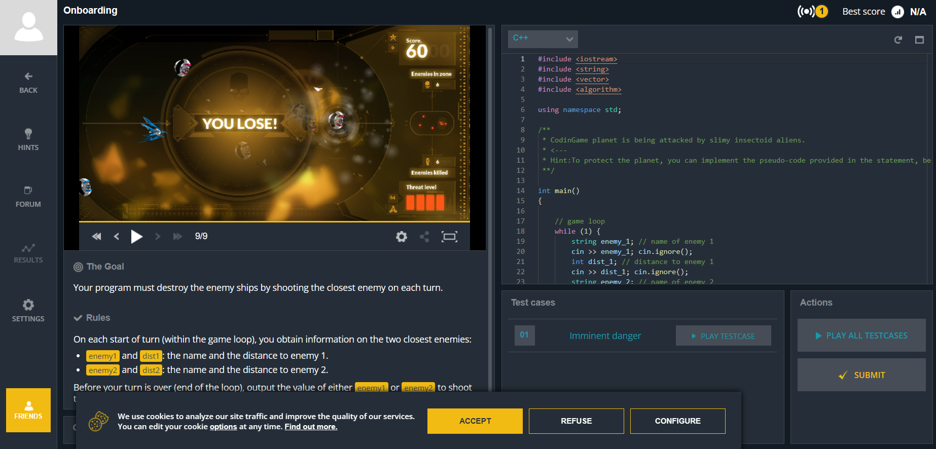

From the perspective of design I don't think we can use any design formatting from this website.

# 4. CodeCombat -

CodeCombat is another coding website that also focuses on sharpening the coding skills of students who know a little bit of coding. This platform does not teach kids coding from scratch. But help them to master their skills based on gaming styling coding.

Which is in my opinion quite challenging for someone who is just starting in programming.

And this is not something that we are focusing on right now.

But in the future if we decide to add something like coding games for intermediate kids who know a little bit of coding then we can check the CodeCombat gaming area section.

Also currently they only use JavaScript and Python as their main language to play a game.

And in a country like India i dont think this type of model will work too.

## Design point of view -

From the design point of view also there is not any particular section that we can pick. Yeah but for sure the website looks professional.

## Screenshots -

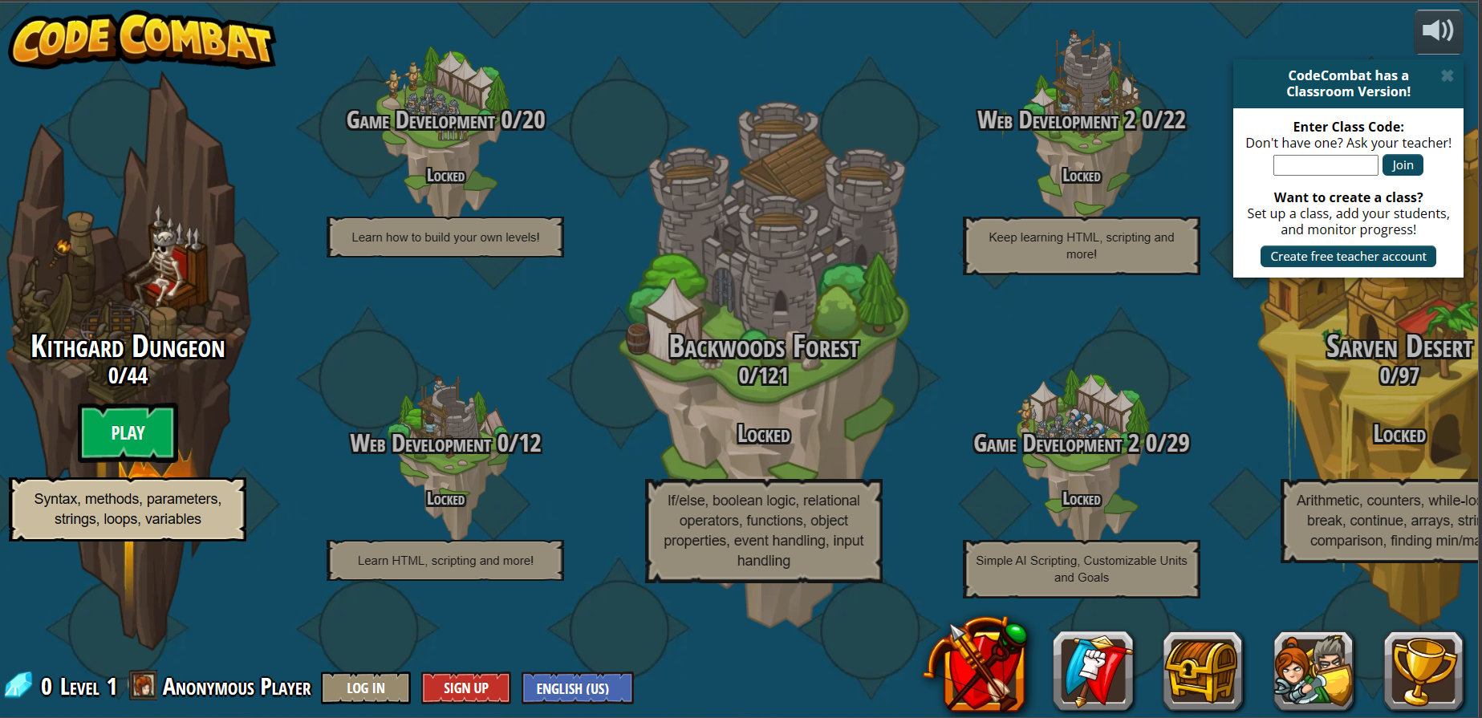

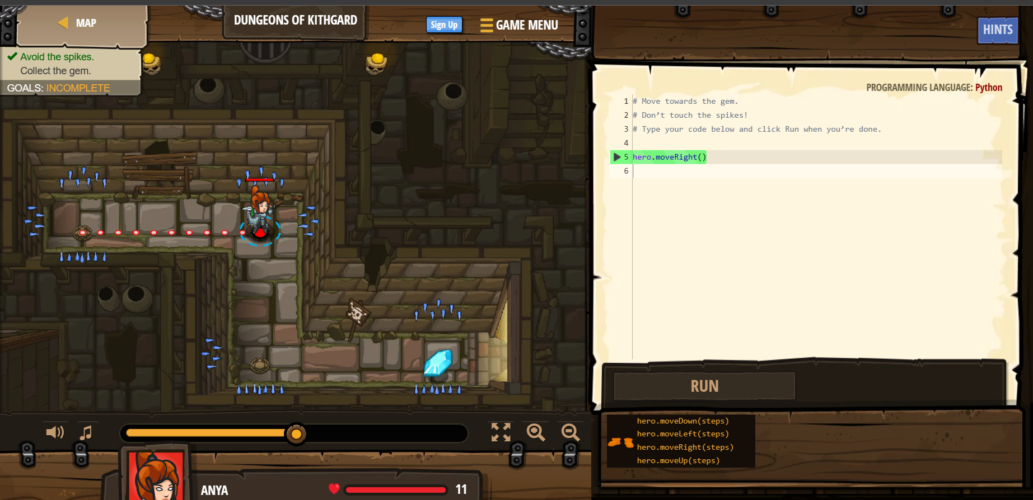

# 5. Codepip -

Like codingame and codecombat, codepip is another coding learning platform. That again is not for kids who are just coming to learn programming or for kids who are in lower grades. For this platform again we need some prior knowledge to play these game style coding challenges.

But as compared to the other two platforms the games in this platform are more kid friendly and easy to navigate and play. Plus it also focuses on smaller topics like css functionality and html. Which can be a good start for any student who knows a little bit of these things.

But again it is worth checking their gaming section to take reference in future.

## Design point of view -

From a design point of view their gaming section where all their games are aligned looks quite neat and good. So it is something to check out for.

## ScreenShot -

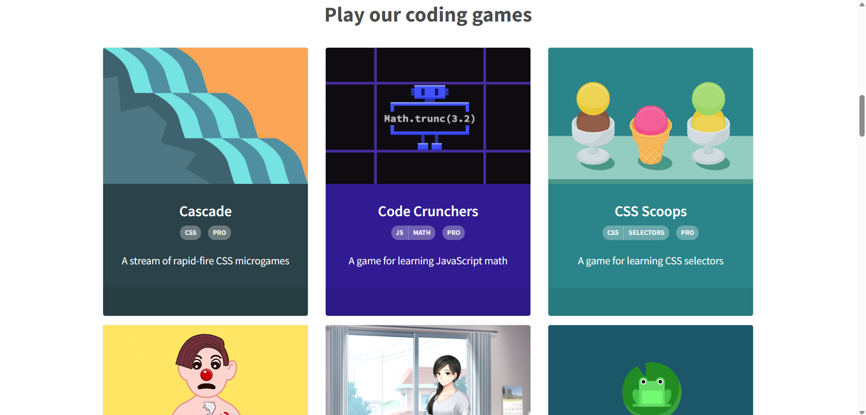

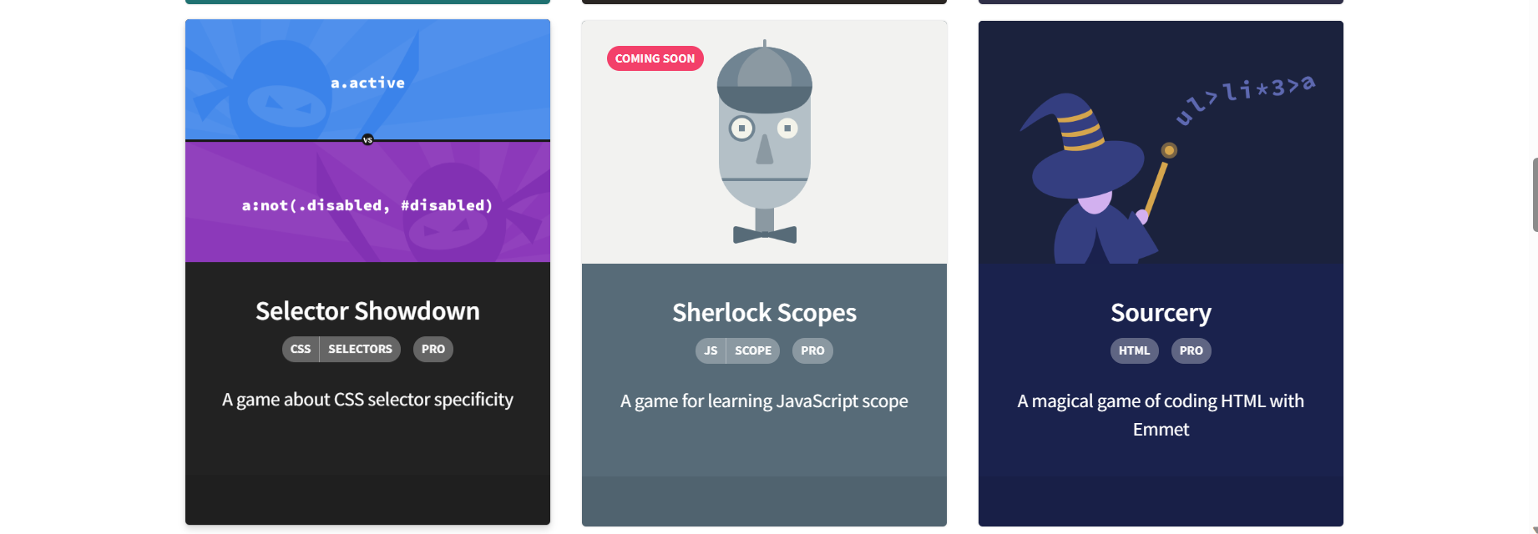

# 6. PbsKids -

PBSKids are the platform that most connects with our vision. Their content are the one that we are trying to build. Like there are hundreds of games in a video format that are interactive and specially designed for kids who are in the early age of learning.

Games look cool and feel like movies but at the same time kids can control the action of the games. And learn different things about different topics visually.

So the Games section of this platform is the one that we should watch and take some inputs from it.

Also at the same time there is another section in the platform called videos but unfortunately it is inaccessible to persons who are out of the US.

## Design Point of view -

Home page of this website is quite interesting because from the first look it looks like it is childish but at the same time if you use it feel very simple and minimalistic. So the layout of the whole site is also quite interesting.

## Screenshots -

